 |  |  |  | DISTRIBUTION
PROJECT | UNR-Mathewson | REPORT # | 006
LOCATION | Reno, NV | TRIP DATE | 04/24/2024
PROJECT # | A9941.01 | ENGINEER/Observer | Hannah Bonotto
CLIENT | LMN Architects | TODAY’S DATE | 4/26/2024
CONTRACTOR | Clark Construction | PAGE | 1 OF 4

OBSERVATIONS/ACTIVITY
Time: 1:00 pm
Weather: Sunny 65 °F
Present: Clark Construction – Brian Peart, Chase Johnson
LMN Architects – Hal Eden
Magnusson Klemencic Associates – Hannah Bonotto

Clark, LMN, and MKA walked the UNR Mathewson site to observe the in-progress steel framing at the south end of the site as shown in Figure 1.

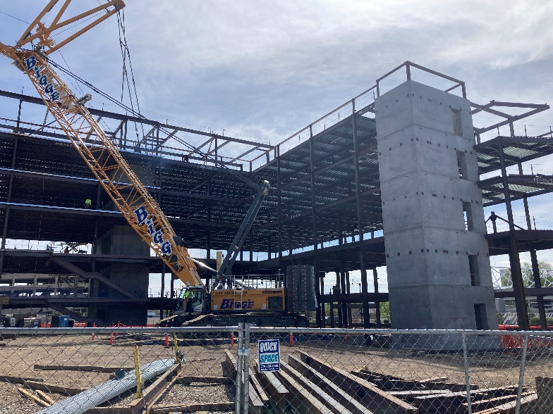
Figure 1. Overall view of steel at south near Stair 3, view looking southeast

- MKA observed the temporary columns and beams at the framing south of Grid 12. Final beam connections were not yet completed.  Action: Contractor to confirm specified tip camber per structural drawings is within tolerance prior to removing temporary shoring. | 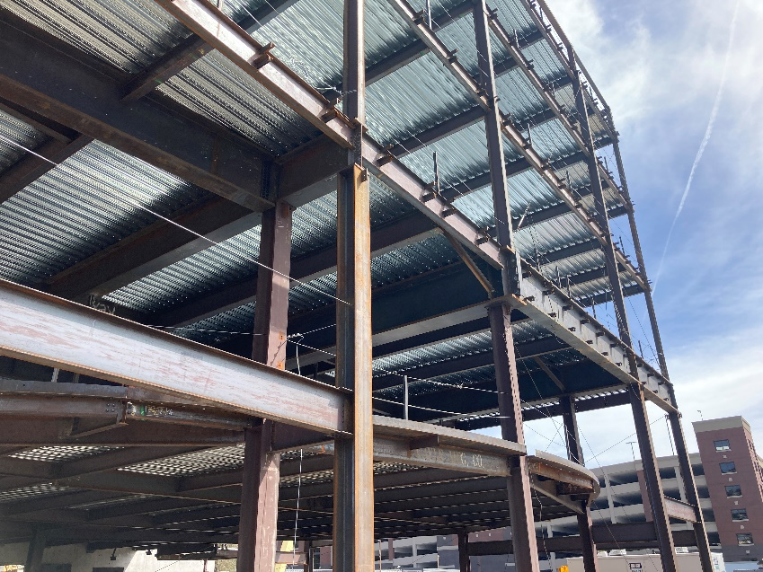  Figure 2. View of L2 and L3 steel and temporary columns and beams
- MKA observed the cantilevered steel structure near Grid 1 at the north end of the site. Temporary columns have been removed. The steel framing appeared to be in general conformance with the contract documents.  Action: None. | 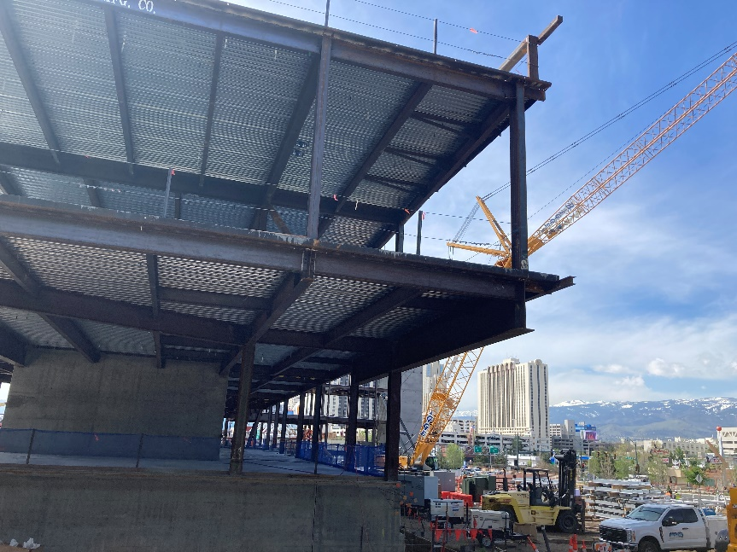  Figure 3. View of L3 and L4 steel framing near Grid 1

- MKA observed the in-progress erection of the penthouse steel. This area was not accessible and viewed only from the ground.  Action: None. | 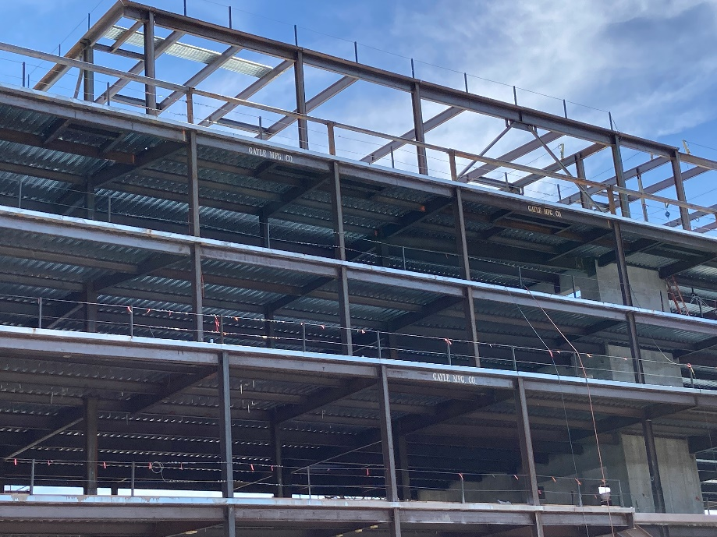  Figure 4. Penthouse steel framing looking east
- MKA observed the top connection at the feature stair near Grid 8.5 at Levels 2 and 3. The as built connection does not allow for movement within the slotted bolt holes shown in detail 2/S602.  Action: Contractor to submit RFI for top connections at Level 2 and Level 3 (four total locations). In RFI, provide dimension from end of top stringer flange to edge of supporting beam flange, distance from stringer web to supporting beam web, and distance from edge of bolt to end of slotted connection in each direction. | 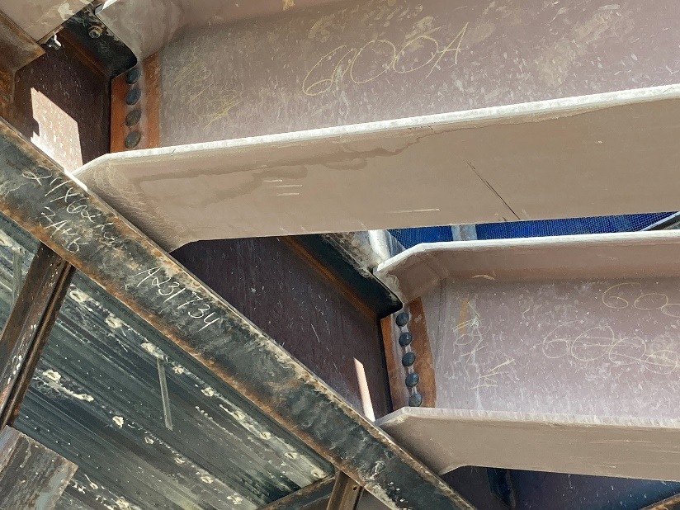  Figure 5. Top connection of feature stair near Grid 8.5
- MKA observed the steel framing at Grid 13 steel drag struts. Welds had not yet been completed at the time of the visit.  Action: None. | 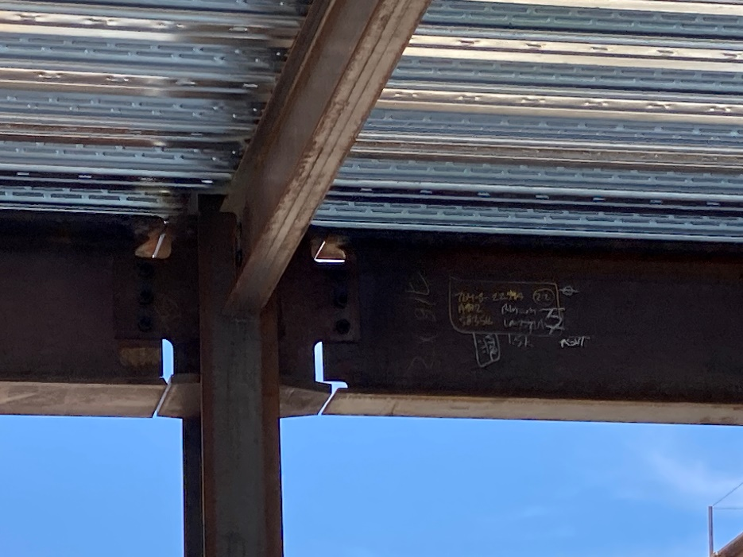  Figure 6. Welded drag connection at Grid 13

I:\UNR_Mathewson\Construction Admin\FieldReports\20240426_UNR_MKA Construction Observation Report_006.docx

